Parth Babbar

Asset Management, Venture Capital & Private Equity

Asset Management:
Asset management entails managing investments on behalf of customers, such as people, businesses, and organizations. The primary aim is to increase the client's assets over time while minimizing risks. Asset managers invest in a broad range of financial products, including equities, bonds, real estate, and alternative investments.
Market Size and Growth:
- As of 2023, the US asset management sector has more over $40 trillion in assets under management (AUM).
- Over the last decade, the industry has grown at a steady pace of around 5% each year.
- The largest asset managers in the United States are BlackRock, Vanguard, and Fidelity, each with billions of dollars in assets.
Key Players:
- BlackRock: The world's largest asset manager with approximately $8.59 trillion in AUM.
- Vanguard: Known for its low-cost index funds, with over $8.1 trillion in AUM.
- Fidelity: A diversified financial services corporation with approximately $4.9 trillion in assets under management.
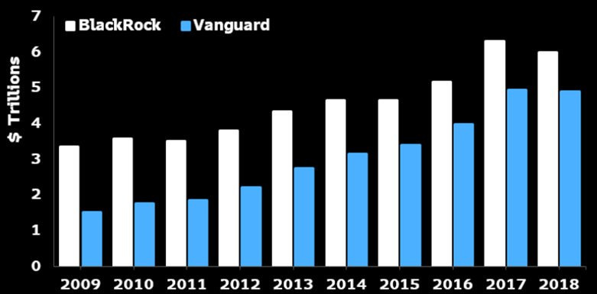
Asset Classes:
- Equities: Stocks of firms, domestic and foreign.
- Fixed Income: Bonds and other debt securities.
- Real Estate: This includes both commercial and residential properties.
- Alternative Investments: Hedge funds, private equity, commodities, and others.
Trends and Innovation:
- ESG Investing: Environmental, social, and governance (ESG) considerations are becoming increasingly important in investment decisions.
- Robo-Advisors: Automated, algorithm-driven financial planning services are more popular.
- Passive Investing: There is a rising preference for index funds and ETFs.
Challenges:
- Regulatory Changes: The asset management sector is subject to severe rules.
- Market Volatility: Changes in market circumstances might affect asset prices.
- Technology Integration: Adjusting to new technology can be difficult.
Solutions:
- Regulatory Changes: Provide regular compliance training and invest in legal knowledge.
- Market Volatility: Diversification and risk-management techniques.
- Technology Integration: Investing in technology and providing employee training.
Statistics:
- Growth Rate: Between 2013 and 2023, the asset management industry will grow at a CAGR of 5%.
- Market Share: Passive funds currently make about 40% of the whole US mutual fund market.
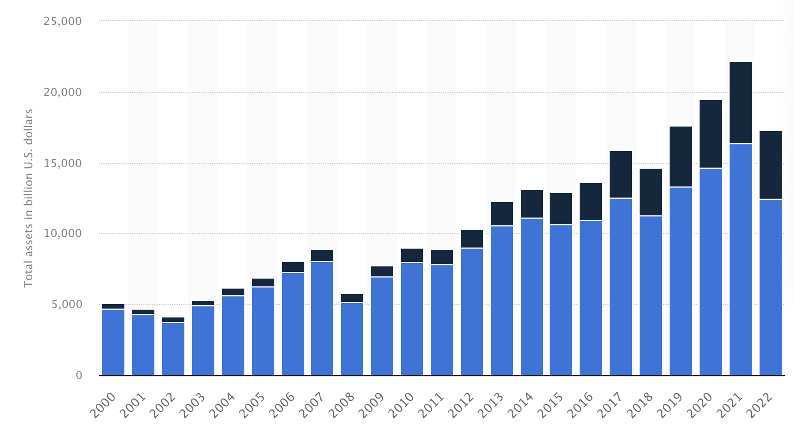
- ESG Funds: In 2020, ESG funds saw an inflow of $51 billion, up from $21 billion in 2019.
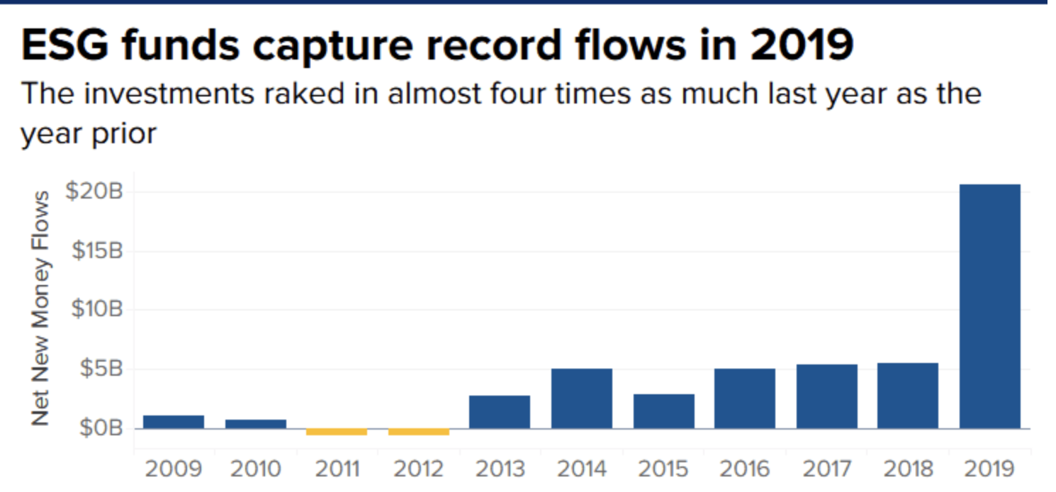
Conclusion:
The US asset management sector, which manages more than $40 trillion in AUM, is evolving as technology advances, investor tastes vary, and regulations change. By tackling issues like as regulatory compliance, market volatility, and technological integration, asset managers may traverse difficulties and maintain growth in an increasingly competitive world.
Venture Capital and Private Equity:
Venture capital (VC) and private equity (PE) are types of investments in which firms get funding in return for equity. Venture capital often invests in early-stage enterprises, whereas private equity concentrates on more established businesses.
Market Size and Growth:
- The US venture capital sector invested more than $150 billion in businesses in 2023.
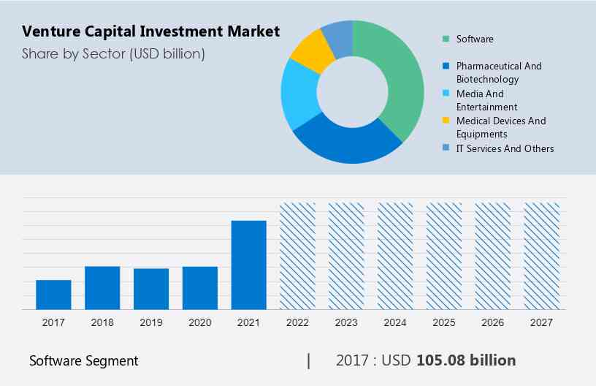
- The private equity market in the United States had a total deal value of more than $700 billion in 2023.
- Over the last decade, both sectors have experienced tremendous growth, with venture capital rising at a CAGR of 10% and private equity growing at 8%.
Key players:
- Venture Capital: Sequoia Capital, Andreessen Horowitz, and Accel.
- Private equity firms: Blackstone Group, KKR, and The Carlyle Group.
Investment stages:
- Venture Capital: During the seed stage, entrepreneurs receive first capital to develop their products. Initially, they obtain funding to expand operations. In the late stage, firms seek finance as they approach an exit or IPO. Each stage is critical to a startup's development and commercial success.
- Private Equity: Growth capital entails investing in mature firms that want to expand. Buyouts include purchasing a controlling position in a firm. Distressed investments are made to help struggling enterprises turn around.
Trends and Innovation:
- Tech Focus: Significant investments in technology industries such as artificial intelligence, finance, and biotechnology.
- Effect Investing: Investing with the goal of creating both a social and environmental effect as well as a financial return.
- Cross-Border Investments: There is an increased interest in foreign prospects.
Challenges:
- Valuation Pressures: Increased competition can raise firm values.
- Departure Opportunities: Identifying effective departure strategies might be challenging.
- The Regulatory Environment: Navigating complicated regulations.
Solutions:
- Valuation Pressures: Conduct thorough due diligence and use disciplined investment tactics.
- Exit Opportunities: Building strong networks and alliances for IPOs and acquisitions.
- Regulatory Environment: Staying abreast of regulatory developments and maintaining compliance.
Statistics:
- VC Funding: $170.6 billion of VC was invested in 15,766 transactions.
- PE Deals: In 2023, the average size of a private equity transaction was $500 million.
- Sector Allocation: Technology accounted for 40% of VC investments, while healthcare received the most PE investments (30%).
Conclusion:
Venture capital and private equity serve critical roles in stimulating innovation, promoting growth, and driving economic development in the United States. By addressing issues like as valuation pressures, exit plans, and regulatory difficulties, investors may seize opportunities and contribute to the dynamic growth of these investment sectors.

